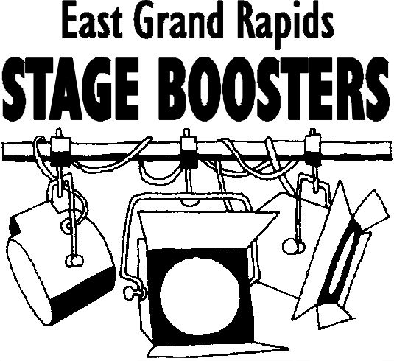
Be DRAMATIC! Join EGRHS Stage Boosters
Support your student and the EGRHS Drama program by joining Stage Boosters. Members are listed in the show programs, and receive advance ticket privileges. Stage Boosters meet the 2nd Tuesday of the month at 7 p.m. (during the school year) in the H.S. Media room. Please join us!

Name:
Address:

Home Phone: Work/Cell Phone:
email address:
Name of student(s) involved and grade (if applicable):

Membership Levels: Member ($40) Patron ($75) Benefactor ($76 & above)
Checks payable to: EGRHS Stage Boosters
Mail to: Wendy Thong
1700 Robinson Rd SE
Grand Rapids, MI 49506

